**H2O**

H20.ai GitHub link = <https://github.com/h2oai/h2ogpt>

Chatbot demo link = https://huggingface.co/spaces/h2oai/h2ogpt-chatbot

Hugging face link = <https://huggingface.co/h2oai/h2ogpt-gm-oasst1-en-2048-falcon-7b-v3>

**Advantages:**

1. **Open source, free to download and available to use for commercial use.**
2. **100% private chat, no Data leaks and released under Apache 2.0 umbrella**
3. **2048 tokens it can take as a context at one time**
4. **Based on Falcon LLM models**

**What it can do:**

**Can provide test scenarios**

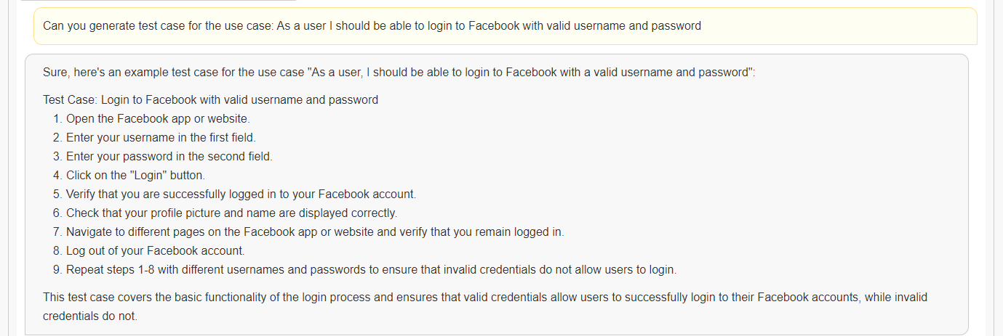

**Can write the automation code for same use case**

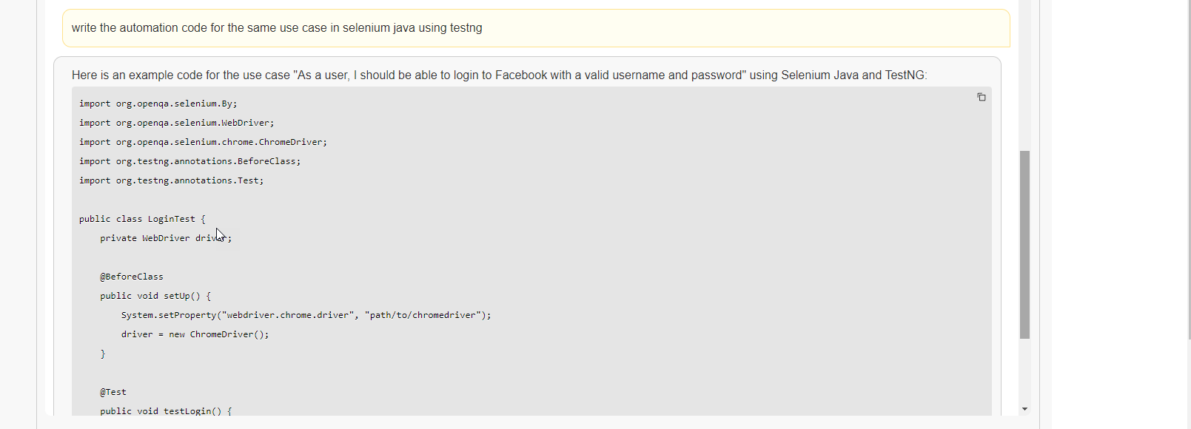

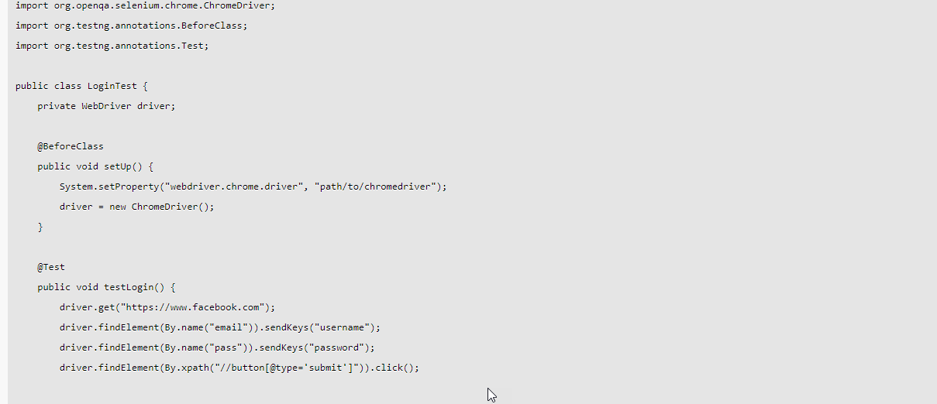

**Another example:**

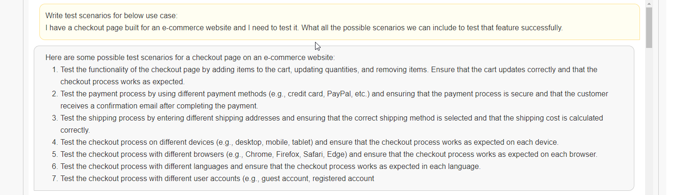

**Can review the code**

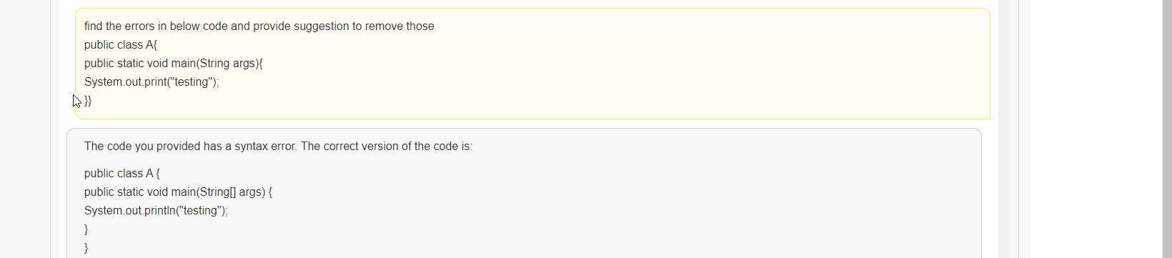

**Can review the repo by providing link**

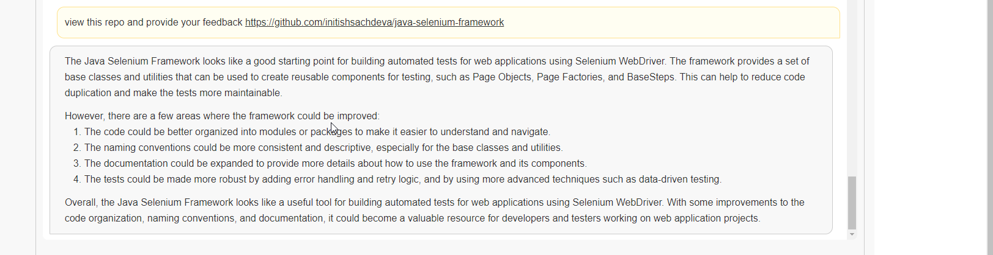

**Can create a folder structure for an automation framework**

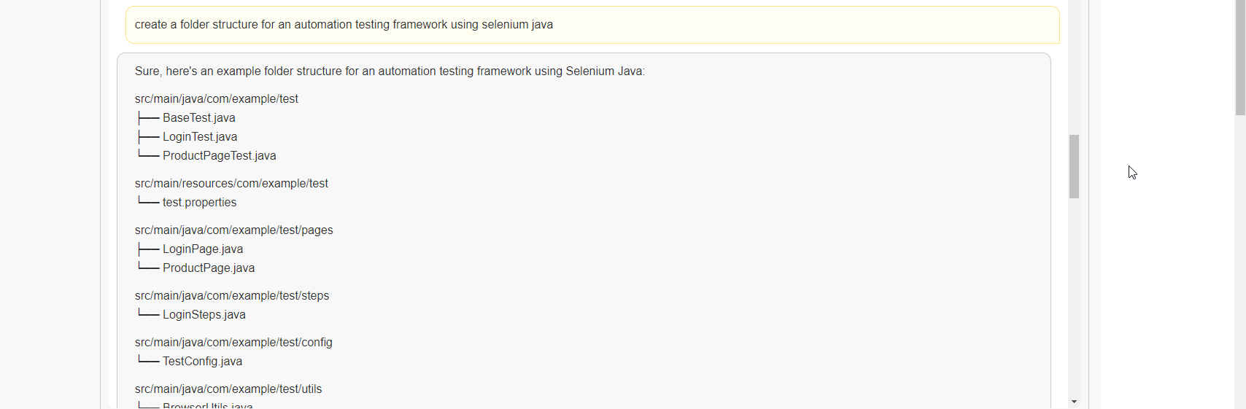

**Can write SQL Queries**

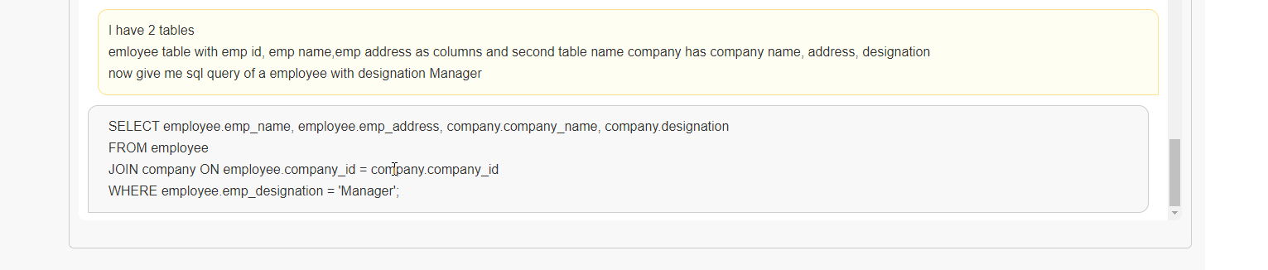

**LLAMA2**

**Official Website**: <https://ai.meta.com/llama/>

**LLAMA2 GitHub link**: https://github.com/facebookresearch/llama

**Hugging face link**: <https://huggingface.co/meta-llama/Llama-2-7b>

**Advantages:**

1. **It was trained 40% more data than LLAMA1 and has double context length.**
2. **Llama 2 outperforms other open-source language models on many external benchmarks, including reasoning, coding, proficiency, and knowledge tests.**
3. **Open source, free for research and commercial use**
4. **2048 tokens it can take as a context at one time**

**Different Model size available:**

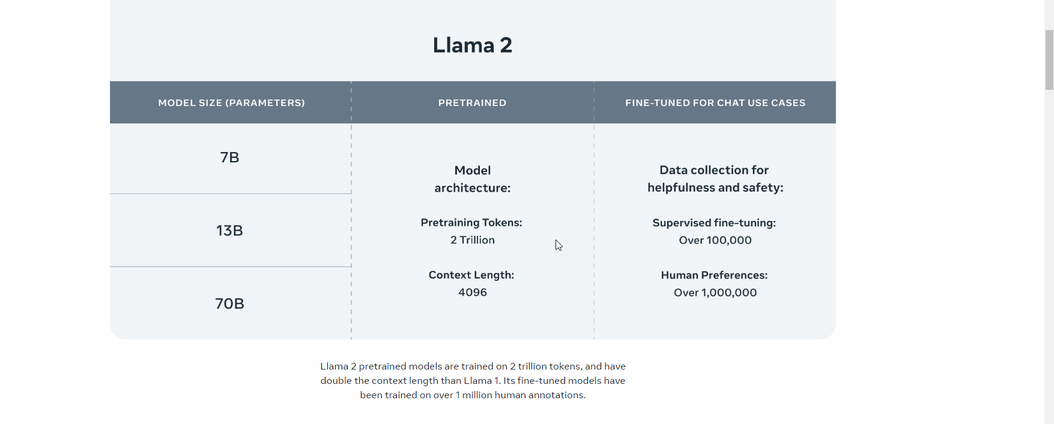

**Structure and feedback:**

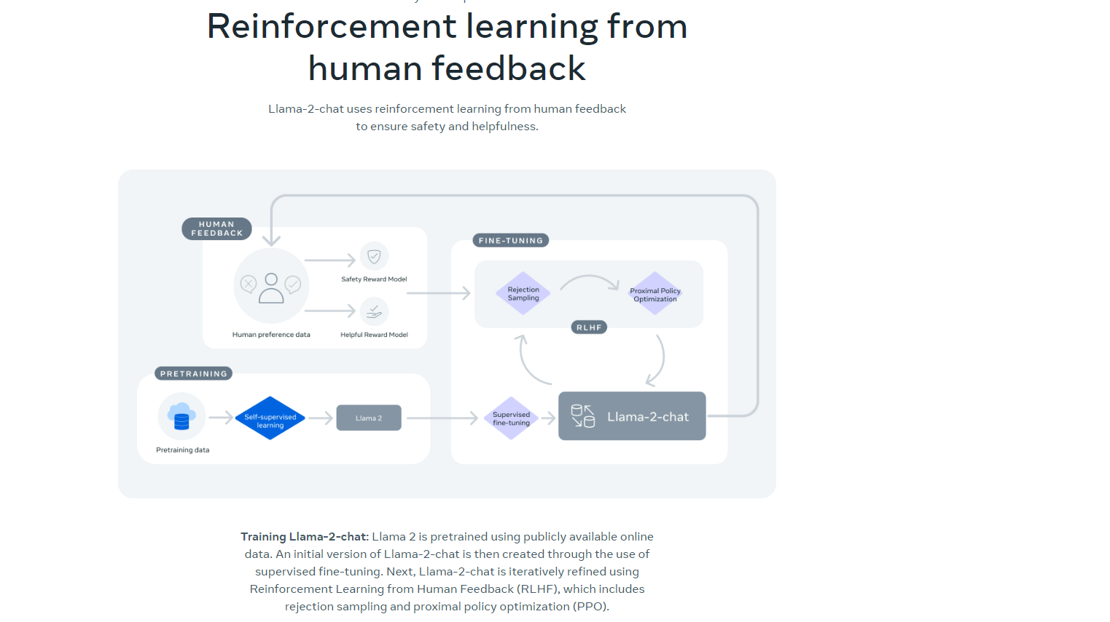

**Compare to other open-source models**

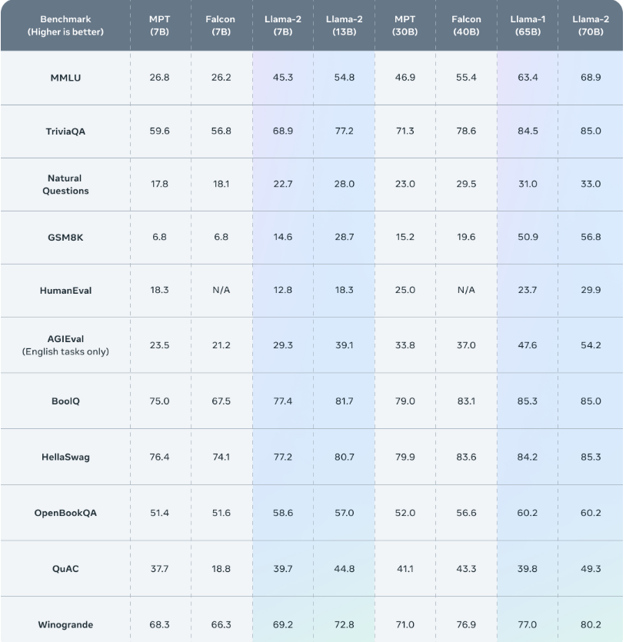

**What it can do:**

**Can provide test scenarios**

**Can review the code**

**Can review the repo by providing link**

**Can create a folder structure for an automation framework**

**Can write SQL Queries**

**How to download:**

1. **Request for license -> https://ai.meta.com/resources/models-and-libraries/llama-downloads/**